27. Create a base class basic_info with data members name ,roll no, sex and two member functions getdata and display. Derive a class physical_fit from basic_info which has data members height and weight and member functions getdata and display. Display all the information using object of derived class
CODING:
#include<iostream.h>
#include<conio.h>
#include<stdio.h>
class basic_info
{
char name[25];
int rno;
char sex;
public:
void getdata();
void putdata();
};
void basic_info::getdata()
{
cout<<"Enter name: ";
gets(name);
cout<<"Enter rollno: ";
cin>>rno;
cout<<"Enter sex: ";
cin>>sex;
}
void basic_info::putdata() // member function definition
{
cout<<"\n\n\tFOLIO:\n";
cout<<"Name : "<<name<<endl;
cout<<"Roll No. : "<<rno<<endl;
cout<<"Sex : "<<sex<<endl;
}
class phy_fit:public basic_info //Simple inheritance
{
float ht;
float wt;
public:
void input()
{
getdata();
cout<<"Enter height(in cms): ";
cin>>ht;
cout<<"\nEnter weight(in kg): ";
cin>>wt;
}
void display()
{
putdata();
cout<<"\nHeight : "<<ht;
cout<<"\nWeight : "<<wt;
}
};
main()
{
phy_fit obj;
obj.input();
obj.display();
getch();
return 0;
}

OUTPUT:

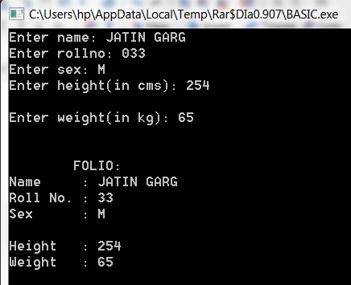

28. Create class first with data members book no, book name and member function getdata and putdata. Create a class second with data members author name ,publisher and members getdata and showdata. Derive a class third from first and second with data member no of pages and year of publication. Display all these information using array of objects of third class.

#include<iostream.h>
#include<conio.h>
#include<stdio.h>
class first
{
int bno;
char bname[50];
public:
void input()
{
cout<<"\nEnter Book No. ";
cin>>bno;
cout<<"\nEnter Book name: ";
cin>>bname;
}
void output()
{
cout<<"\nBook No. : "<<bno;
cout<<"\nBook Name : "<<bname;
}
};
class second
{
char author[25];
char publisher[25];
public:
void indata()
{
cout<<"\nEnter Author: ";
cin>>author;
cout<<"\nEnter Publisher: ";
cin>>publisher;
}
void outdata()
{
cout<<"\nAuthor : "<<author;
cout<<"\nPublisher : "<<publisher;
}
};
class third:public first,public second
{
int pgn;
int yr;
public:
void in()
{
input();
indata();
cout<<"\nEnter number of pages: ";
cin>>pgn;
cout<<"\nEnter Release year : ";
cin>>yr;
}
void out()
{
output();
outdata();
cout<<"\nNumber of pages: "<<pgn;
cout<<"\nRelease Year : "<<yr;
}
};
main()
{
clrscr();
third t[5];
int i,n;
cout<<"No. of details to be entered: ";
cin>>n;
for(i=0;i<n;i++)
{
t[i].in();
}
for(i=0;i<n;i++)
{
cout<<"\nDETAIL NO. "<<i;
t[i].out();
}
getch();
return 0;
}

output:

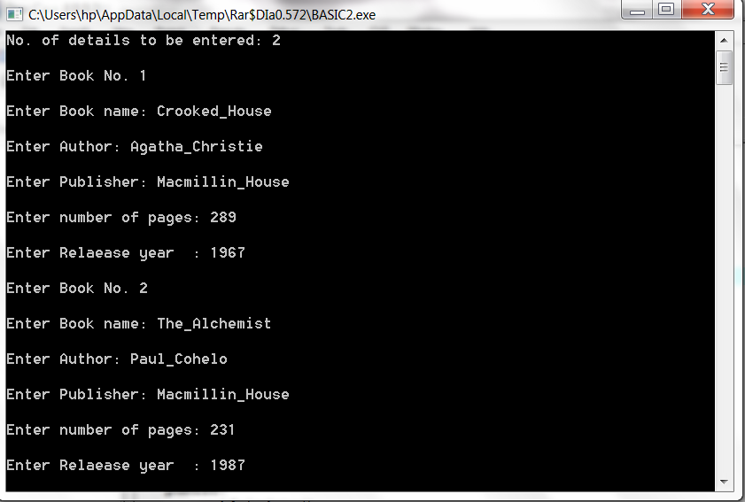

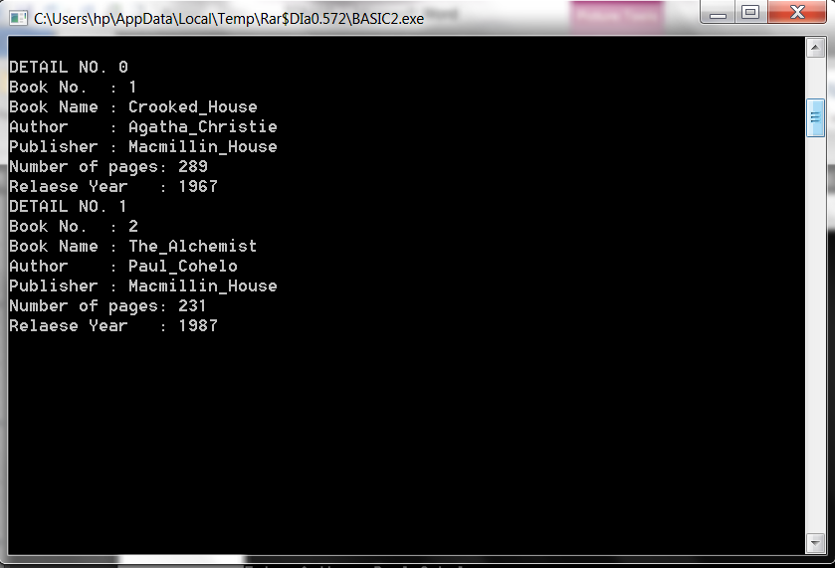

29. Design three classes STUDENT ,EXAM and RESULT. The STUDENT class has datamembers such as rollno,
name. create a class EXAM by inheriting the STUDENT class. The EXAM class adds datamembers representing the marks scored in six subjects. Derive the RESULT from the EXAM class and has its own datamembers such as totalmarks.Write a program to model this relationship.

CODING:
#include<iostream.h>
#include<conio.h>
#include<stdio.h>
class student
{
char name[25];
int rno;
public:
void input()
{
cout<<"\nEnter name: ";
gets(name);
cout<<"\nEnter roll no: ";
cin>>rno;
}
void output()
{
cout<<"\nNAME : "<<name;
cout<<"\nROLL NO. : "<<rno;
}
};
class exam: public student
{
float mks[6];
public:
void indata();
float add();
};
void exam::indata()
{
int i;
input();
cout<<"\nEnter marks in six subjects (out of 100):\n";
for(i=0;i<6;i++)
{
cin>>mks[i];
}
}
float exam::add()
{
int i=0;
float sum=0;
for(i=0;i<6;i++)
{
sum=sum+mks[i];
}
return sum;
}

class result: public exam
{
float tm;
float per;
public:
void display()
{
tm=add();
per=tm/6;
output();
cout<<"\nTotal Marks: "<<tm<<"/600";
cout<<"\nPercentage : "<<per<<"%";
}
};
main()
{
clrscr();
result r;
r.indata();
r.display();
getch();
return 0;
}

OUTPUT:

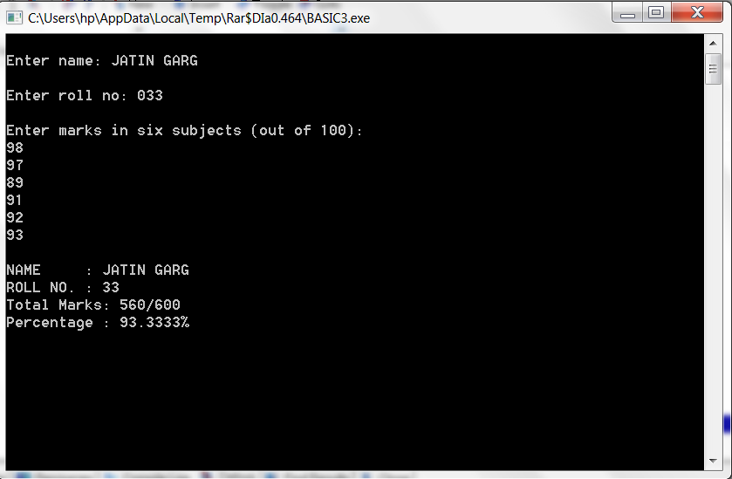

30. Write a program to demonstrate the order of memory allocation and de-allocation to objects.
coding:
#include <iostream.h>
#include <string.h>
#include<conio.h>
const int MAX_SIZE = 10;

class A
{
private:
char* string;
static int counter;

public:
A();
~A();
};

A::A(){
string = new char[strlen("Object") + 1];
strcpy(string, "Object");
cout << "Constructing Object " << ++counter << endl;
}

A::~A(){
cout << "Destroying Object " << counter-- << endl;
delete [] string;
}

int A::counter=0;

int main()
{
A* Aptr = new A[MAX_SIZE];
delete [] Aptr;
getch();
return 0;
}
output:

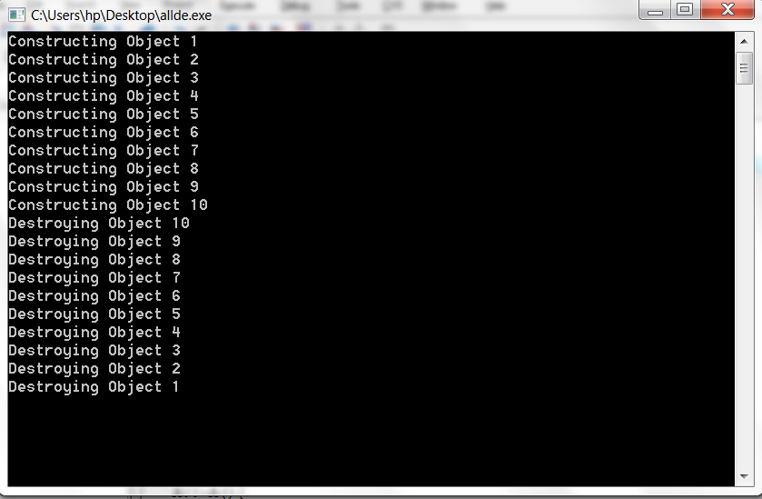

31. Write a program to demonstrate the use of constant member functions and constant objects of a class.

coding:
#include <iostream.h>
#include<conio.h>

class Increment
{
private:
int count;
const int increment; // const data member
public:
Increment(int c = 0, int i = 1);
void addIncrement() { count += increment; }
const void print();

};

// Constructor for class Increment
Increment::Increment(int c, int i): increment(i) // initializer for const member
{ count = c; }

// Print the data
const void Increment::print()
{
cout << "count = " << count
<< ", increment = " << increment << endl;
}

main()
{
Increment value(10, 5);

cout << "Before incrementing: ";
value.print();

for (int j = 1; j <= 3; j++) {
value.addIncrement();
cout << "After increment " << j << ": ";
value.print();
}

getch();
return 0;
}

output:
